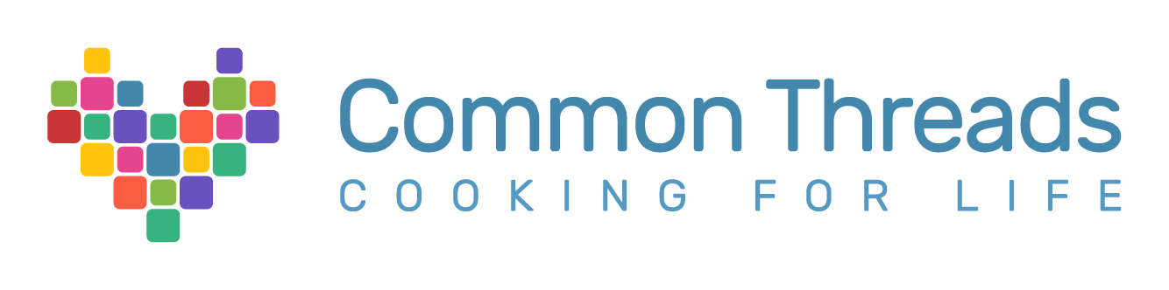
Common Threads Awareness Campaign
“Food is Medicine”

Solutions Agency
Germanie Bozeman
Carese Brown
Stacy Choi
Olivia Cooper
Osiris Padilla

Common Threads Client Overview:
Common Threads is a national nonprofit organization that focuses on providing children and families cooking and nutritional education. Common Threads encourages families to adopt healthy habits to promote wellness in their daily lives. They believe that food is medicine and work hard to spread this message to under-resourced communities. Common Threads prides themselves in promoting diversity by including tradition and culture in their lessons and recipes to celebrate the world. Common Threads strives to make their curriculum more accessible to more communities.

Campaign Goals and Objectives:
Common Threads is looking to add 10,000 engaged millennial subscribers over the course of 12 months to their newsletter. The goal is to be able to encourage these subscribers for donations in the future. They want to emphasize the message that food is medicine using their multiple online assets. This campaign will be kicked off in January 2023.

Research:
Our research consisted of a few things. First and foremost, we did a website analysis for the official Common Threads website. We used the website “Popsters” to run analytics and found that Common Threads received eighteen thousand monthly visits in the last two months. We also found that visitors would spend a total of a minute and thirty seconds on the website and that 60.9% of their audience consisted of women with the other percent being of men and other persons. Common Threads’ sign-up for their newsletter took a little bit of effort from the visitor to look for and was a little long.

We also did a social media analysis where we ran their Facebook, Instagram, and Twitter accounts (as these were the ones featured on their website) through Popsters. We found that all three accounts had an engagement rate of less than 1%. We also looked through their accounts to see what they consisted of. As visitors click on their accounts, they are greeted with their logo as the profile picture of their accounts and a short but sweet introduction that let visitors know what Common Threads focused on. We found that all their social media accounts were family oriented, with pictures of families engaging in nutritional cooking. There were rarely any videos being shared. They post almost daily with the exception of the weekend. Their Facebook account had the most followers from the three social media accounts, which we can infer that is because most parents are on social media.

We decided it would be important for us to do research on the target audience of millennials. According to the Pew Research Center, millennials are those between the years of 1981 to 1996. Millennials also favor convenience. And to help our campaign, we took a look at some colors that would help us how create engaging posts for a new audience. Color-meanings.com states that the color blue symbolizes trust and loyalty and that the color green symbolizes harmony and health.

Target Audience:
Common Threads is looking to increase their millennial subscriber count, meaning that our primary target audience are millennials. Millennials is a very broad term, so we decided to create two characters that would fit the millennial age but are more specific to our campaign.

Our primary audience are millennial mothers. We named our persona Jessica. Jessica is a millennial mother of three that lives in New York City, New York. She favors nutrition over price and convenience. She believes the lunches she makes for her children are very nutritious and organic. She shops for brands that promote safety, healthiness, nutrition and education. Jessica prefers to shop in person rather than online but is very active on social media.

Our secondary audience is our single father, Matthew. Matthew lives in Chicago, Illinois. He takes fewer shopping trips and isn’t someone who shows loyalty to brands, (we would need to fix that). He is very busy and works long hours to provide for his children. He doesn’t always make healthy cooking decisions, especially because he wouldn’t know where to even begin.

How do we attract them to Common Threads’ brand?

Strategy:
To increase awareness and engagement between millennials and Common Threads’ using their Facebook, Instagram and Twitter accounts while also implementing knowledge of health and well-being with featured food.

Tactics:
Clean up social media feeds to increase visibility and transparency, (this would include choosing two main colors to portray in posts [green and blue], and posting less wordy captions and more informational graphics):
- Create weekly posts on Instagram with specific themes to get the target audience excited to engage on the account. Ideas include “Sunday Dinner Recipes to Try” for the millennial mother, “1-Pot Meals/Air Fryer Fridays” for both our millennial mothers and single fathers as these posts will provide easy and quick recipes for anyone to do, cooking/healthy educational reels where they would make short tutorial videos of their recipes being made as well as the ingredients being explained for what purpose they serve, and recipe of the week challenges with their hashtag “Food is Medicine.”
- On Facebook and Twitter, Common Threads can develop contests and giveaways and establish their website URL link to put on their posts.
- All three social media accounts can all have live videos of prominent figures of the company participating in nutritional cooking to show audience that those in charge really care about their message, can post on their stories daily (even during the weekends) recipe videos or even educational videos on nutrition, and can include a link tree URL on their posts.
- A Link-tree would provide a more linear flow where Common Threads would be able to provide multiple links to their content in one space, making it convenient for visitors to find all their information. Their newsletter sign-up can be the first on the list and can then link their website and social media accounts as well as their donations page. The Link-tree URL can be posted along with posts and can be put in the bios on their accounts.
- Use popular hashtags under posts to gain more traffic for their posts, (i.e. #foodie #foodforthought #foodlove #health).
- Create posts with recipes that include information on why specific ingredients are healthy to use.

New Year’s Resolution:
- An interactive idea for the healthy millennial to kick off on January 2023. The new year always counts for people wanting to eat healthier and becoming better versions of themselves. Common Threads can post a social media campaign with the hashtag “#NewYearNewEats.” New healthy recipes can be posted for those that want to start the year right.

Back to School Hacks:
- The message of “Food is Medicine” can be spread through their social media pages by beginning a “back to school” campaign where Common Threads can create school box-lunches for parents to make for their kids going back to school in the month of August.

9/11 Remembrance Post:
- Common Threads was inspired after 9/11, when Chef Art Smith and artist Jesus Salgueiro spent time cooking for New York families impacted by the devastating event. It is important for people to know that this is a root for the company, so always making a post on 9/11 would be ideal.

Website Recommendations asked for:
We recommend the creation of a pop-up newsletter sign-up option, meaning that when visitors get on their website, the first thing they will be greeted with would be the sign-up for their newsletter instead of having visitors look for where to sign-up. We also recommend shortening the information needed to sign-up for the newsletter to something simple like first name, last name, email, and “which role best describes you?” The newsletter should also be more appealing to the eye and contain the color blue and green to show trustworthiness and health. When the visitor signs up for the newsletter, it should take thirty minutes to an hour to receive a welcome letter.

When it comes to their recipes online, we believe a “flip-book” cookbook version of their recipes would be a fun interactive way for visitors to “flip” through the many healthy recipes they provide.
Timeline:
Kick-off of campaign awareness strategies should begin on January 2023 to run the course of 12 months, preparing Common Threads for their 20th Anniversary campaign in 2024.

Summary:
Our campaign will help Common Threads achieve their goal of getting 10,000 millennial subscribers to their newsletter. This campaign is budget friendly, and helps emphasize the importance of Common Thread’s mission and values.

